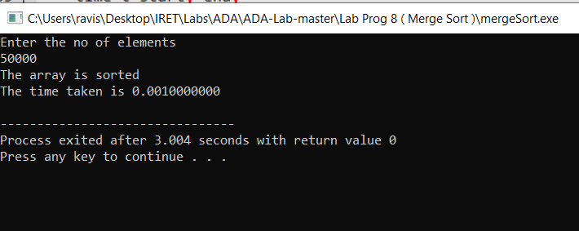

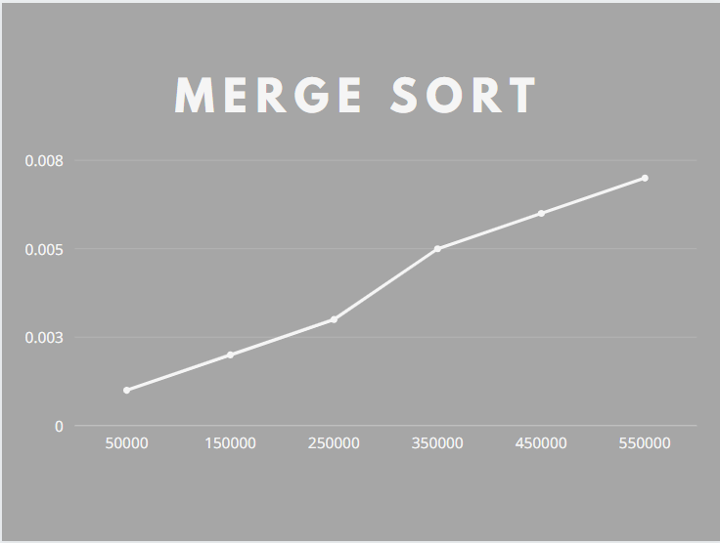

|  |  |
| --- | --- |
| Merge Sort  Array size | Time in sec |
| 50000 | 0.001 |
| 150000 | 0.002 |
| 250000 | 0.003 |
| 350000 | 0.005 |
| 450000 | 0.006 |
| 550000 | 0.007 |